Carbon Dioxide Emissions and Temperature Stabilization

Introduction:
Climate change is complex. While the scientific community is still investigating specific changes expected within our climate, there is consistent agreement regarding the major causes. One of these causes is the release of CO2 into our atmosphere mainly from the burning of fossil fuels. If greenhouse gases continue to increase, climate models predict that the average temperature at the Earth's surface could increase from 3.2 to 7.2ºF by the end of this century.

Purpose:
In this activity, you will investigate CO2 emissions by region / country and explore changes in emissions needed to stabilize the Earth’s temperature. You will be using the Java Climate Model , JCM, to complete this lab. The JCM is based on scientific formulae from Intergovernmental Panel on Climate Change- Third Assessment Report , IPCC-TAR, and can replicate key TAR predictions. It is also evolving further to investigate new research questions.

Procedure:
1. Using Safari, open the Java Climate Model http://jcm.climatemodel.info/
2. “try it now, launch, allow,
3. At the top, middle, under “scenario type ” select “SRES No-Climate-Policy-scenarios”

Your screen should look similar to this image:

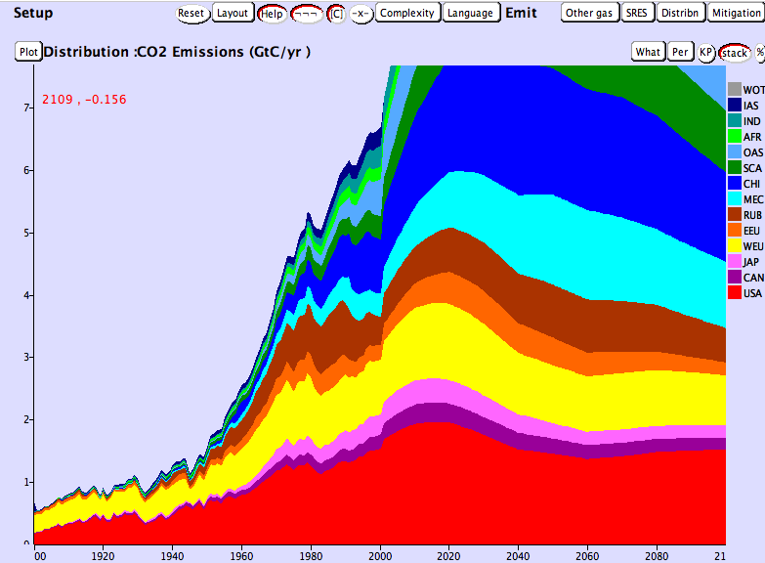

This graph shows you the amount of carbon dioxide emitted by various countries and regions (in giga tons). Think of this as a stack of pancakes of various thicknesses. The thickness of the “pancake” tells you the amount of CO2 for that country (see the Y axis). The Country Key is found on the right of your screen. Place the curser over the various colors to see the country name.
In the year 2000, list the top 3 CO2 emitting countries / regions:
1.
2.
3.

Now go to the projected data for the year 2060. list the top 3 CO2 emitting countries / regions:
1.
2.
3.

In the top middle, change scenario type to “stabilization”
This graph now shows you what CO2 emissions must become to stabilize the Earth’s temperature. In other words, we must reduce our CO2 emissions to these amounts.
- In the year 2000, how many giga tons of CO2 did the USA emit?

- According to this model, what level should the USA be at in the year 2100?

- Covert this to a percentage:

Future CO2 x 100 =
Current CO2

Analysis:

- What are some specific things the USA can do to reduce fossil fuel use?

- Look at your estimated percent CO2 reduction. Do you think the USA can reduce emissions by this amount by the year 2100?

- What is something you can personally do in your lifetime to reduce CO2 emissions?

4. Write down 1 question you have about this lab activity.

